**Tensorflow and keras install in Virtual Environment on Windows**

**Also install atom with hydrogen**

**Last amended: 14/11/2018**

It is assumed that Anaconda in already installed. We will first create a virtual environment. A virtual environment is like an isolated container for holding python related packages.

The same steps should also work for Mac machines.

1. Open Anaconda prompt as Administrator (see figure below)

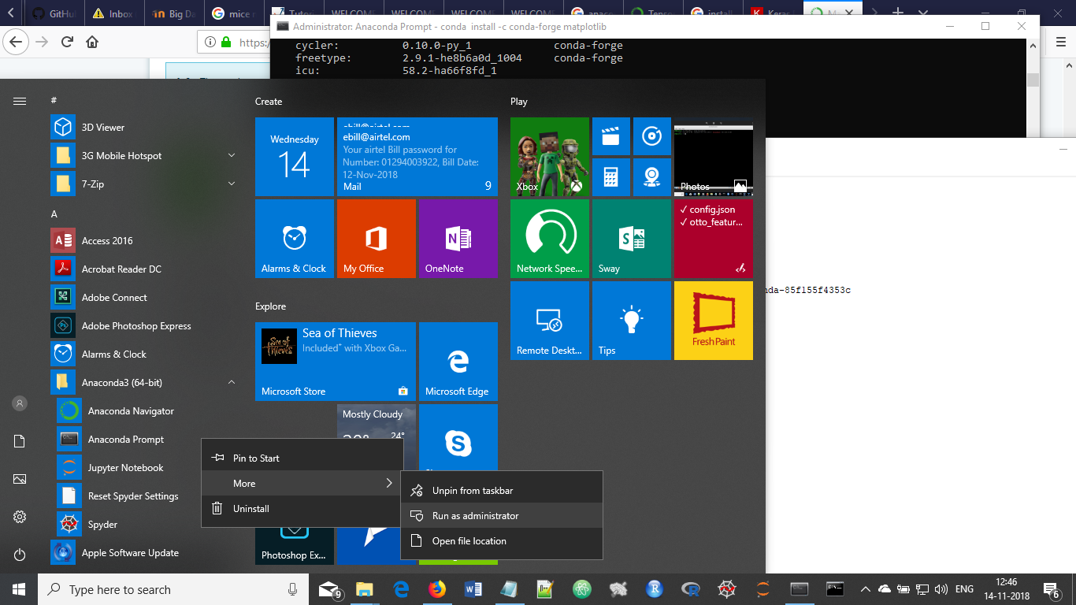

Figure : Open Anaconda Prompt as Adminstrator

ii) Create 'tensorflow' virtual environment and install tensorflow

(Ref: https://www.anaconda.com/blog/developer-blog/tensorflow-in-anaconda/)

conda create -n tensorflow_env tensorflow

iii) Activate virtual environment *tensorflow_env* :

(Ref: https://www.tensorflow.org/install/)

conda activate tensorflow_env

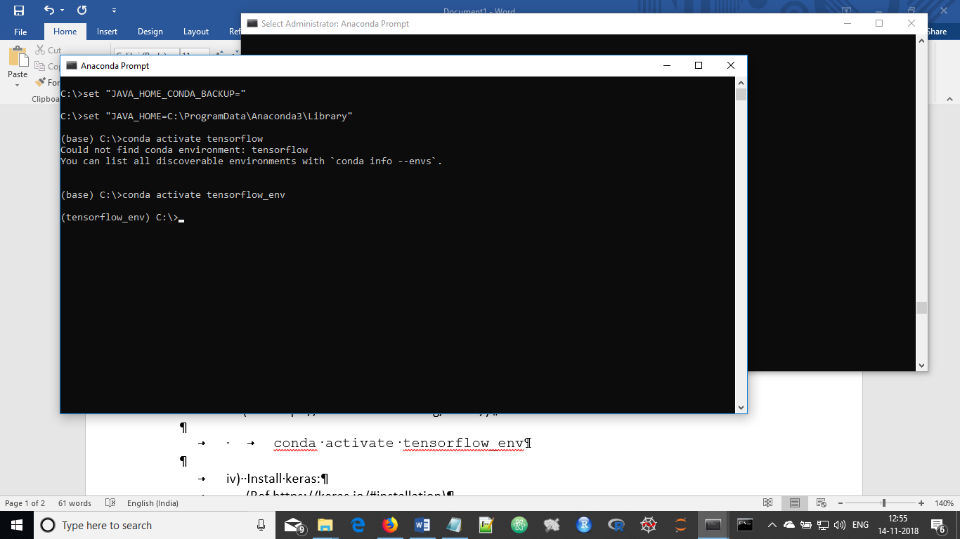

Figure 2: Prompt after activating tensorflow_env. Note the special prompt with tensorflow_env in brackets.

iv) Install keras:

(Ref https://keras.io/#installation)

pip install keras

v) Install some other utilities:

conda install -c anaconda ipython

conda install -c conda-forge Matplotlib

conda install -c anaconda jupyter

vi) Test as follows:

a) Start Anaconda prompt as ordinary user

b) Activate tensorflow environment:

conda activate tensorflow_env

c) Start ipython

ipython

d) The following package import should not give any error:

import numpy as np

from keras.datasets import cifar10

from keras.models import Sequential

from keras.layers import Input, Convolution2D, MaxPooling2D, Dense

e) Quit *ipython*

f) Deactivate *tensorflow_env*:

conda deactivate tensorflow_env

############ Install atom & hydrogen ##################################################

i) Close Anaconda Prompt, if open.

ii) Install ‘*atom’* editor by downloading 64bit for Windows from

this site: *https://atom.io*/

ii) Close/quit ‘atom’ editor, if started after installation.

iii) Open Anaconda Prompt as **Administrator**

iv) Activate *tensorflow_env*, as:

conda activate tensorflow_env

v) In the Anaconda prompt itself, write, *'atom'* to start *'atom'*

in this environment (see below).

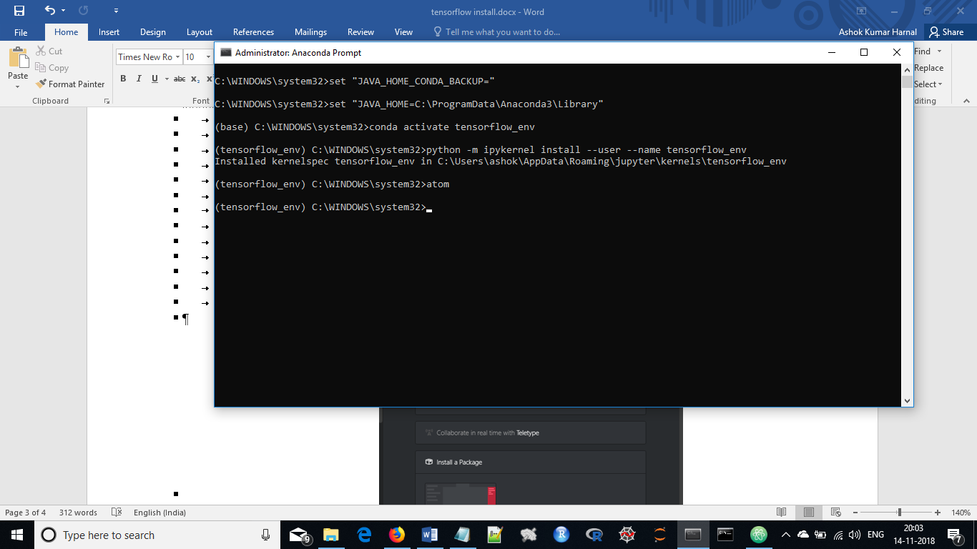

Figure : Starting atom from tensorflow_env.

vi) After *'atom'* has started, install package: ***'Hydrogen'*** (see below):

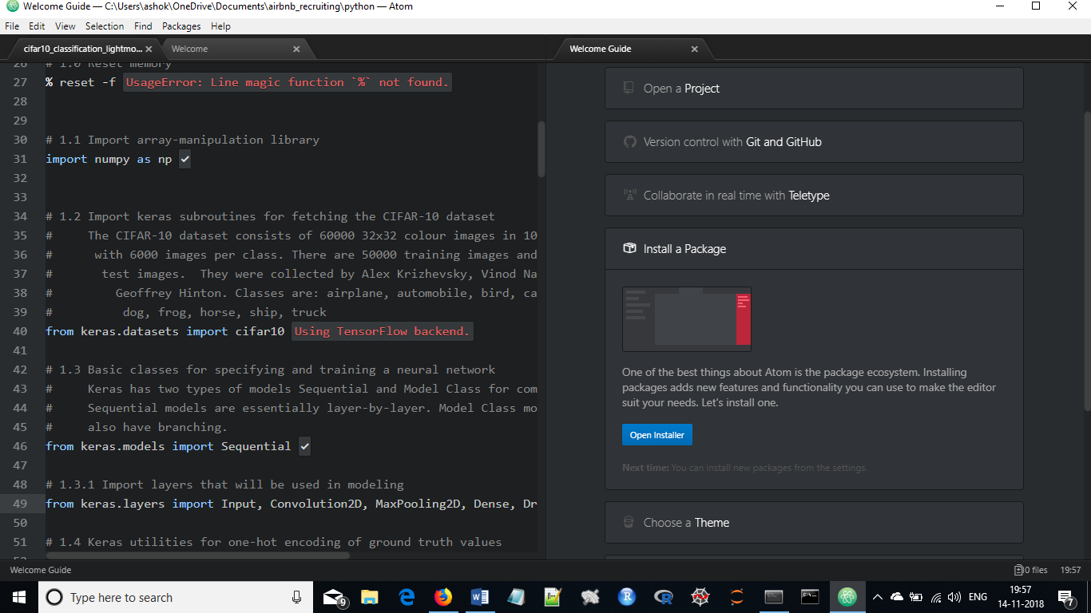

Figure : Under ‘Welcome Guide’ tab, click Open Installer button

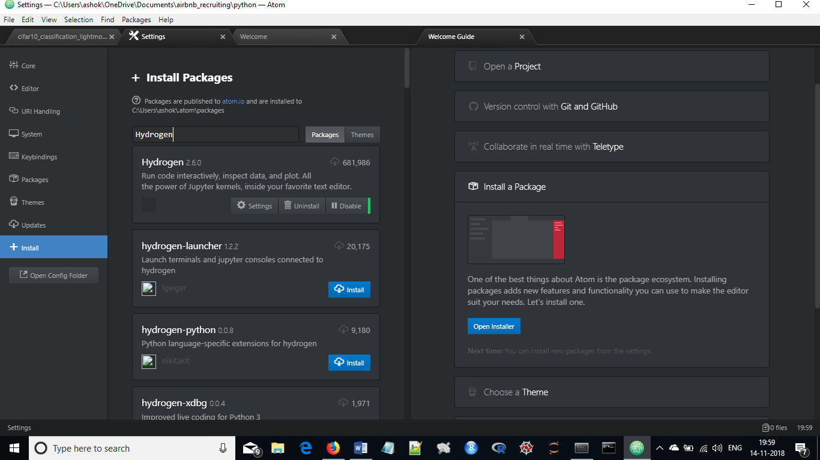

Figure 5: Search for Hydrogen package. And click on **Install** to begin installing of Hydrogen. After installation you will get three buttons as above.

vii) After installation is complete, quit/close ‘atom’, but NOT Anaconda prompt.

ix) Issue and execute the following instruction in Anaconda Prompt (still as Administrator)

(not sure if this instruction will work for Mac machines):

> python -m ipykernel install --user --name tensorflow_env

x) Done

*************